 | FM-37/IOM-MHAC/ SOP/LAB/Advice Sheet Covid-19  CLIENT ADVICE SHEET FOR COVID-19 testing | FORM
 | Rev.: 01 of 8th August 2022

INFORMATION SHEET

Once your referral is received, IOM Laboratory will contact you to inform you of your appointment date and time for the specimen collection. IOM payment details will be provided with the test fee in Kenya shilling equivalent to 45 USD. Please make the payment prior to your booking date and time.

On the appointment date, please proceed to IOM Clinic according to your appointment time, wearing your face mask and observing other Covid-19 measures. The security guard will confirm your appointment and provide hand sanitizer before inviting you to enter the clinic. You will be asked to present your National ID/passport prior to specimen collection for the purpose of identification.

REQUIRED DOCUMENTS:

1. Valid passport or National ID

CLINIC LOCATION: House number 78 UN Crescent, off UN Avenue, Gigiri, Nairobi, Kenya

Please proceed to the lower gate (Gate C) of IOM closer to the Trademark Hotel (Village Market) back entrance. Please check the map on the second page. GPS coordinate: -1.2326478, 36.8045023
CONTACT DETAILS:

Landline Number: +254 709 890232

Mobile Number: +254 110 875651

E-mail: iomnbocovidlab@iom.int

COVID-19 TESTING HOURS:

Monday to Friday; 7:00am – 10:00am (Except for National/IOM Holidays)

PAYMENT:
Payment is accepted via MPESA or Bank Deposit or prior agreement with the corresponding UN Agency only. IOM will provide payment details with your specific account number and the amount in Kenya shillings.

The FEES:
Kenya shilling equivalent to $45 (USD)

*IOM accepts walk-in applicant for Covid-19 Testing between 08:00 am-10:00 am weekdays*.

 | FM-37/IOM-MHAC/ SOP/LAB/Advice Sheet Covid-19  CLIENT ADVICE SHEET FOR COVID-19 testing | FORM
 | Rev.: 01 of 1st August 2022

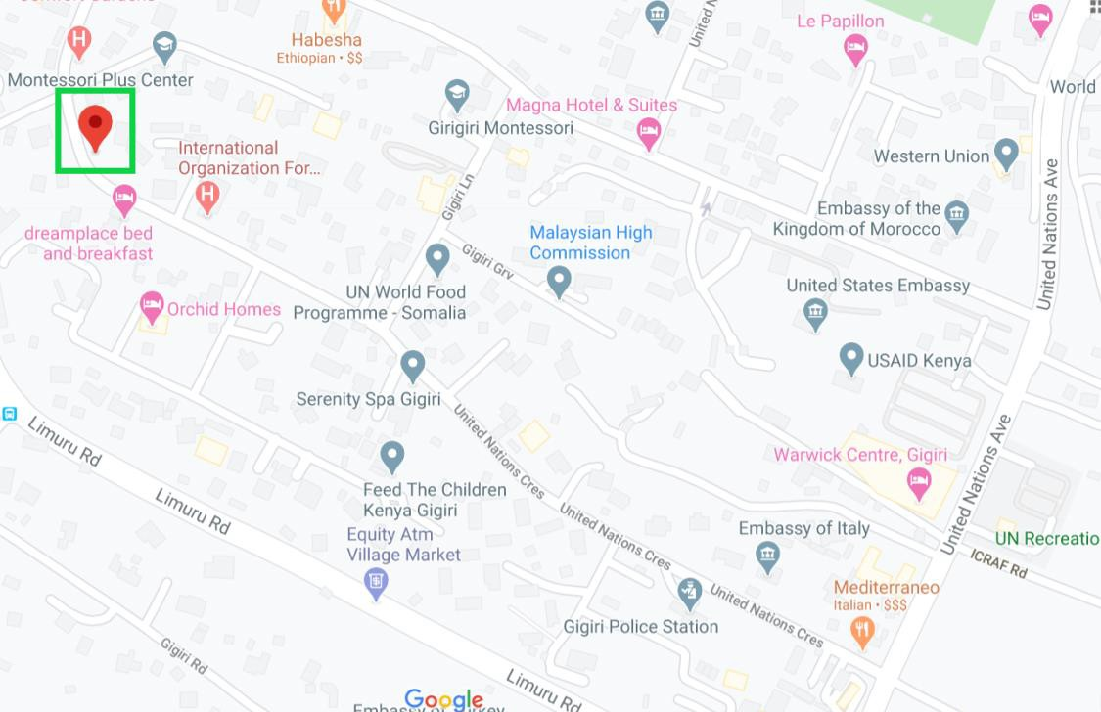
1Directional Map to IOM Nairobi Lab

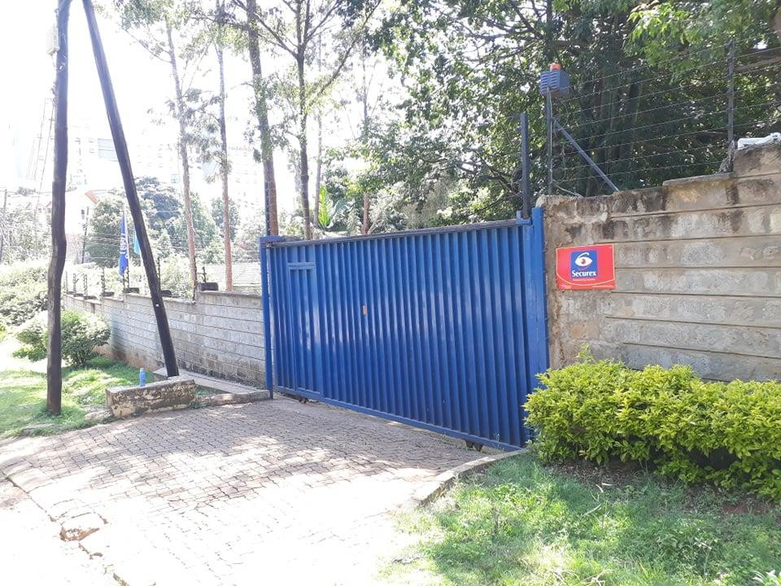
2Front Entrance of IOM Nairobi Lab

